1. 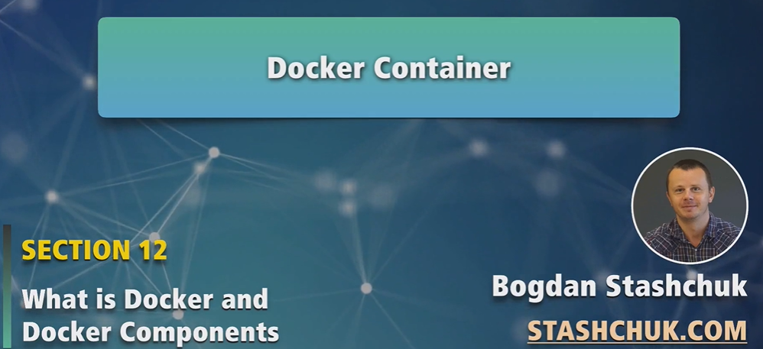
2. Docker image is just a set of files layer which are read-only and we can’t modify them.
3. But if you create custom image using already existing image, of course we can add another files on top of existing files.   
   But Docker images are used to create Docker Container.
4. 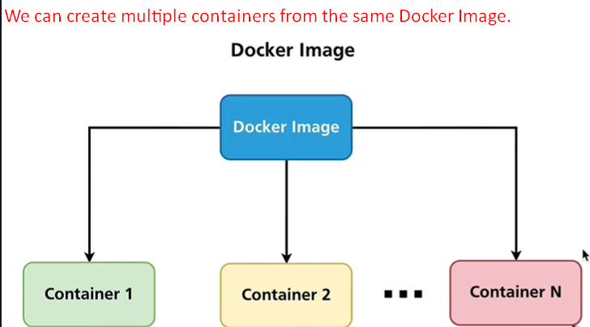  
   NOTE: So how many images you can create depends on the amount of the resource on your Docker Host.
5. Let me demonstrate it.
6. 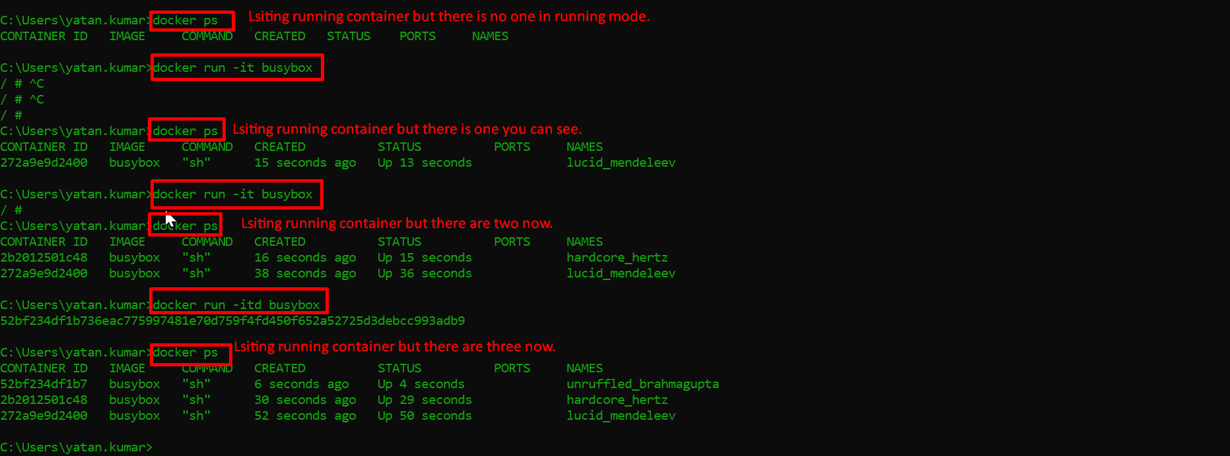
7. Docker run -it ImageName  
     
   -d option would not wait for the process to complete to come to command prompt.
8. **NOTE**: Every container has writeable layer that means you’re able to modify container.  
   **For Example**: we can create files inside the container but not inside the image.  
   